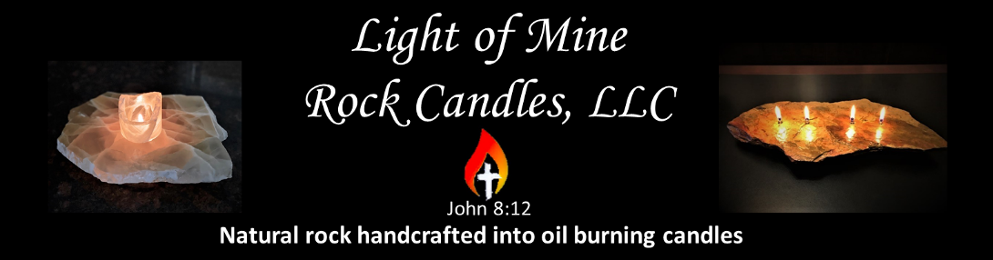

Instructions for Rock Candles
- Measure up to ¼ cup (2 oz) of fuel with a drip-free
measuring cup, or use the 2-ounce sample bottle provided.
- Place the funnel into the smaller fill hole in the candle.
If your candle does not have an extra fill hole, pull the wick out
and place the funnel in the wick hole.
- Slowly pour up to ¼ cup fuel into the funnel & fuel bowl below.
DO NOT OVERFILL…This will affect the seal of the fuel bowl!
Caution: spilled fuel can damage furniture.
- Allow a few minutes for the oil to soak up to the top of the wick.
- Then light your candle & enjoy.
- BLOW CANDLE OUT BEFORE REFILLING.

Additional Tips
- Flame height can be adjusted by pulling the wick up or down in
the glass tube. Wicks should be just barely over the top edge.
- KEEP WICK & FLAME LOW to prevent smoke & soot damage.
- Excessive smoke can also be caused by wind & fans, which
inhibits the fuel from burning completely.
- Store candle indoors or out of direct weather & sunlight.
It will deteriorate over time if left outdoors.
- If rainwater gets into the fuel bowl, remove the wick(s) and pour
out rainwater. Dry completely, insert the dry wicks, then relight.
- KEEP FUEL & CANDLES AWAY FROM CHILDREN AND PETS!!

Each rock candle comes with:
- Sample of our Firefly Clean Fuel
(Note: flammable fuels are not shipped with candles)
- Long-lasting fiberglass wicks
- Instruction card with fuel suggestions
- Gift or shipping box
- Funnel
281-795-4210
www.LightOfMineRockCandles.com
RockCandles@outlook.com

"I am the light of the world, says the Lord; whoever follows me will have the light of life..." John 8:12
God, help me to be a light to those around me so that when others see my life,
they want to draw closer to you. Matthew 5:16, Eph 5:8

